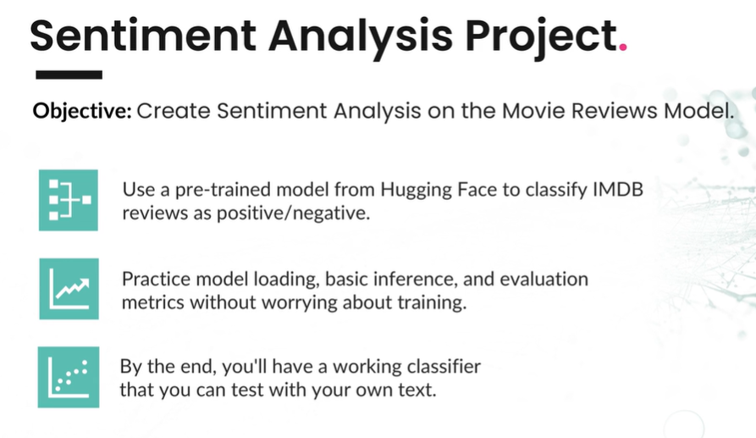

Understanding what you want to achieve first is very important in AI projects!
As this will form the basis for the whole project and determine how much time, money and effort will go into it. AI Projects can range from very simple easy to implement systems to complex projects that require millions of dollars of investment, with a lot more expertise and effort.
In commercial software development it is common for organisations to first gather the requirements for a software project before starting. This process saves a lot of time, money and effort as the project and its objectives are clearly defined which saves organisations from unnecessary effort.
In its simplest form requirements are simply a list of the features or capabilities that will go into a software application. They can range from short high-level lists to complex detailed technical documents of what a program should contain.
Sentiment Analysis AI Project Objective
- Create a sentiment analysis model for movie reviews
- Use a pre-trained Hugging Face model to classify IMDb reviews as positive or negative
- Practice model loading, basic inference, and evaluation metrics without training a model
- Build a working classifier that can be tested with custom text
Sentiment Analysis AI Project Steps
- Set up your environment
- Load a pre-trained model
- Work with real data
- Add interactive testing
- Understand what you have built
- Add proper error handling and edge cases
- Create a visualization of the results
- Write a README documenting what you’ve learned
- Push the project to GitHub as a portfolio example

